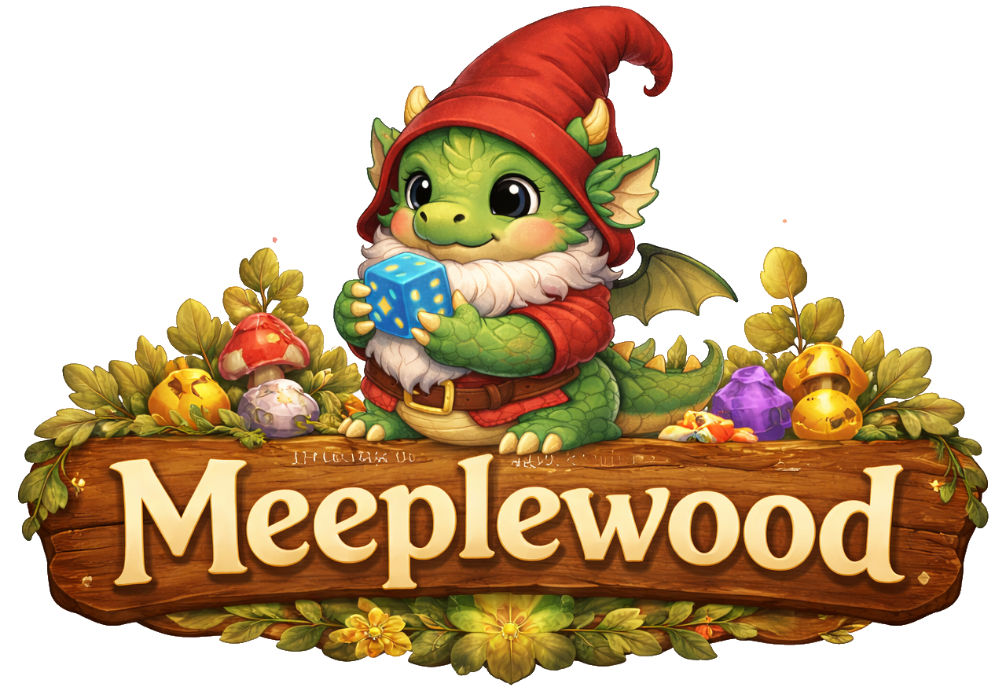
Design Document
Table of content
Introduction 2
Project Overview & Motivation 2
Intended Audience 2
Design Approach Overview 2
Combined Methods 2
Empathize & Define 3
Domain Situation 3
User Analysis 3
Primary user 4
Task analysis 4
Ideate & Prototype 5
Design Ideas 5
Usecase model 5
UC.x 5
Lo-Fi Prototype UC.x 6
User interface design 6
Data Visualisation 6
Data abstraction 6
Visual Encoding 6
Technical Solution and Implementation 6
Used Frameworks 6
System Architecture Overview 6
Component Diagram 6
Class diagram 6
Data Design 6
Interface design 7
References 8

Introduction

Project Overview
Meeplewood is designed around several board game data sources, mainly logged plays from Board Game Stats (Eerko) and collection data exports from BoardGameGeek (BoardGameGeek). The goal is to bring these data sources together in one place and turn them into useful insights and a playful way to explore the data for board game enthusiasts.
The application focuses on two main areas. First, it offers several ways to explore data about logged plays, such as identifying the most played games, play patterns with specific people, winners by game category or genre and might help answering the question “What to play next?” by suggesting games based on different criteria.
The second area is to help organize a board game collection by showing which games are owned, which games may already be covered by other people’s collections and which are on the wanted-list. This includes data from “Spiel preview lists" that are announced via BoardGameGeek every year before Spiel (Spiel).

Intended Audience
Meeplewood is a playful software experiment built to explore programming concepts and try out fun ideas, both on a creative level as well as a software engineering level. It is a personal “because I can” and “practice what you preach” project.
As a teacher at the ICT academy at Zuyd University of Applied Science (LinkedIn Profile), I teach students to develop all kinds of applications in different courses, with a focus on usability engineering and data visualisation. Over the past years, the idea for this project came to mind and I decided to use this to develop an application following the same guidelines I expect from students.
The first version exists therefore mainly for own use and personal development and is not intended to become a fully developed and deployed application. But who knows what the future will bring.

Use of GenAI
AI is not a new phenomenon, but the launch of ChatGPT (ChatGPT) in 2022 changed the world. Instead of ignoring it, I try to use it to my advantage without losing a critical way of thinking and being creative. GenAI is used in this project for a number of reasons:
- Rewriting text: English is not my native language, so AI is used to rewrite text into a more formal and professional writing style.
- Generating images: Before GenAI, only very simple (and probably ugly) user interface elements would have been used. Image generation makes it possible to transform ideas and concepts into fun visual representations.
- Programming: As a software engineer, I already have coding experience and a solid understanding of basic software architecture concepts. This project is mainly used to explore programming concepts and languages that are new to me. AI tools such as GitHub Copilot help me understand unfamiliar concepts and assist in identifying and fixing errors during development.

Design Approach Overview
Depending on the course, different methodologies are taught to students. The design documents for this project follow a hybrid methodology that combines multiple approaches to create a cohesive development process tailored to this project.

Combined Methods
Nested Design Model provides the analytical foundation through three nested levels:
- Domain Situation: understanding the board game tracking context (playing and collecting)
- Data and Task Abstraction: identifying what questions can be answered with the data
- Visual Encoding: designing the visuals to help user answer the questions
Design Thinking drives the creative process:
- Empathize & Define: understanding user needs and pain points
- Ideate & Prototype: generating and testing solution concepts
Agile Development and ‘traditional’ Software Engineering:
- User Stories and iterative development for flexible feature delivery
- Use Case scenarios, UML diagrams, data normalization

Domain Situation
The modern board game world has evolved into a large and structured hobby ecosystem supported by online platforms, communities, and global events. Central to this ecosystem is BoardGameGeek, which functions as a comprehensive global database containing tens of thousands of board games, millions of ratings, and extensive user-generated data. The platform is widely used for recommendation systems, research, and community interaction, making it a key infrastructure within the contemporary board gaming hobby (Woodward & Woodward, 2019) (Xiao, 2025).
Board gaming is no longer limited to traditional family games played occasionally at home. Instead, it has developed into a complex and vibrant hobby characterized by specialized publishers, dedicated media and reviewers, large international conventions, online databases and tracking tools. Strong community interaction and knowledge sharing have further contributed to the growth of this ecosystem, allowing players to exchange experiences, discuss strategies, and evaluate new releases in a collaborative environment.
Board game conventions play a particularly important role in this landscape by bringing together players, publishers, designers, and retailers in large-scale events focused on playing, discovering, and selling games. Major conventions such as SPIEL Essen and Gen Con (Gen Con) attract tens to hundreds of thousands of attendees and serve as central meeting points for the global board game community. With thousands of new game releases presented each year, these conventions function as marketplaces for innovation and community gathering, demonstrating both the scale and the structured nature of the modern board game hobby.
As a result of these developments, the board game world has become a structured hobby environment in which players engage with games in multiple ways. Participation extends beyond simply playing games and includes collecting, reviewing, discussing and analysing them. This multi-layered engagement reflects the maturation of board gaming into a data-rich and community-driven domain, where information, interaction, and shared experiences are as important as gameplay itself.

User Analysis
Researchers are beginning to describe the demographics of board gamers (Cross, Piovesan, Sousa, Wright, & Atherton, 2023), but there is no single official hierarchy to describe a level of board gamer. The board gaming industry consistently recognizes a spectrum based on game weight, hobby involvement and/or complexity preference. For this project, the categories “Casual”, “Hobbyist”, ”Expert” and “Collector” will be used.
In a world full of data, a distinct subgroup has emerged: “data-driven board gamers”. These players are systematically tracking and analysing their board game activity. These players can be found in the category “casual”, but are more likely to be at least hobbyist players.
The existence of play logging features in platforms like BoardGameGeek and specialized tools such as Board Game Stats demonstrates that tracking and analysing gameplay data is a recognized and supported practice within the hobby.
The reason for logging plays and managing collections differs from person to person. An quick online search gave useful information on this topic, mainly forums where people discuss logging plays:
- BGG, January 2023 – Why do you log plays (or not)
- Reddit, June 2025 – Why do you track your plays?
- Reddit, January 2026 – How do you log your games
- BGG, Augustus 2023 – How do you log your games?
- Facebook, January 2026 – What tools do board gamers use to log plays?
Future versions may expand to serve other board game players and, in the far future, local board game stores might be able to use the tool for community features, board game discovery and recommendations. When this happens, a more elaborate user analysis should take place.

Primary user
Design Thinking is a user centred design method and a commonly used quote is “You are not the user”. In this case the developer is also the main and, in first versions, the only user. Therefor, this document will focus on features desired by the primary user only.
Characteristics:
- Receptivity to playful, themed interfaces when core functionality remains reliable.
- High technical proficiency and comfortable with file import/export operations (JSON, XLS).
- Strong interest in data insights, statistical analysis and content categorization.

Analysis of Existing Applications
Within the board game world, different applications are used to log play sessions and manage board game collections.
- Functionality Comparison
- User Usability Evaluation
- Software Components and Architecture
- Strengths and Weaknesses
- Summary and Design Implications

Task analysis
Typical functionalities for data-driven gamers include logging every game played; tracking players, scores, wins and losses; recording playtime and locations; managing and analysing their game collection; monitoring play frequency and trends; using statistics to evaluate their gaming habits; integrating tools and databases into their hobby. For these players, board gaming becomes both a social and analytical activity.
Define:
- Which tasks are core vs. supporting.
- Task decomposition.
- Task-to-feature mapping.
- User Stories

What tasks users perform:
- Maintain a comprehensive overview of their board game collection.
- Identify patterns in play frequency, wins, and player preferences.
- Streamline game selection to reduce decision friction.
- Experiment with novel features for personal enjoyment.

Design Ideas
- Theme
- Overall look -and-feel

Use case model
- UC-Diagram and overall description

UC.x
Use Case​ | <Unieke code>: <Unieke, beschrijvende naam voor de use-case>​
Beschrijving​ | <Korte beschrijving (max 5 zinnen) die uitlegt wat de UC doet>​
Actor(en)​ | <Welke Actor/Actoren voeren deze use-case uit?>​
Trigger(s)​ | <Situatie(s) waaronder de use-case wordt gestart, meestal gelijk de 1e stap>​
Pre-conditions​ | <Optioneel; Alle voorwaarden, die noodzakelijk waar zijn voordat de use-case wordt gestart>​
Post-conditions​ | <Wat is het resultaat van een succesvol verloop van de use case>​
Steps​ | <stappen die uitgevoerd (kunnen) worden tijdens de use-case. ​  Links = acties vanuit de actor; rechts = acties vanuit het systeem>​
 | 1. ​  3.​  4.​  …​ | 2.​  5. ​
Main Succes Scenario​ | <volgorde van stappen voor het belangrijkste (meest voorkomende) succesvolle scenario>​
Alternative Scenario’s​ | <volgorde van stappen voor alle overige scenario's ; geef telkens een naam voor het scenario en of deze wel of niet succesvol is>​

Lo-Fi Prototype UC.x

References
BoardGameGeek. (n.d.). Retrieved from https://boardgamegeek.com/
Boumans, R. (2026). Github repository. Retrieved from https://github.com/Excali8ur/Meeplewood
Cross, L., Piovesan, A., Sousa, M., Wright, P., & Atherton, G. (2023). Your move: An open access dataset of over 1500 board gamer’s demographics, preferences and motivations. Simulation & Gaming, 54(5), pp. 554-575.
Eerko. (n.d.). Board Game Stats. Retrieved from https://www.bgstatsapp.com/
Gen Con. (n.d.). Retrieved from https://www.gencon.com/
LinkedIn. (n.d.). Retrieved from https://www.linkedin.com/in/rianneverheijen/
Spiel. (n.d.). Retrieved from https://www.spiel-essen.de/en/
Woodward, P., & Woodward, S. (2019, Oktober). Mining the Boardgamegeek. Significance, pp. 24-29.
Xiao, T. (2025). Analysis of Factors Influencing Board Game Ownership Based on A Gradient Boosting Model. Theoretical and Natural Science, pp. 16-24.

